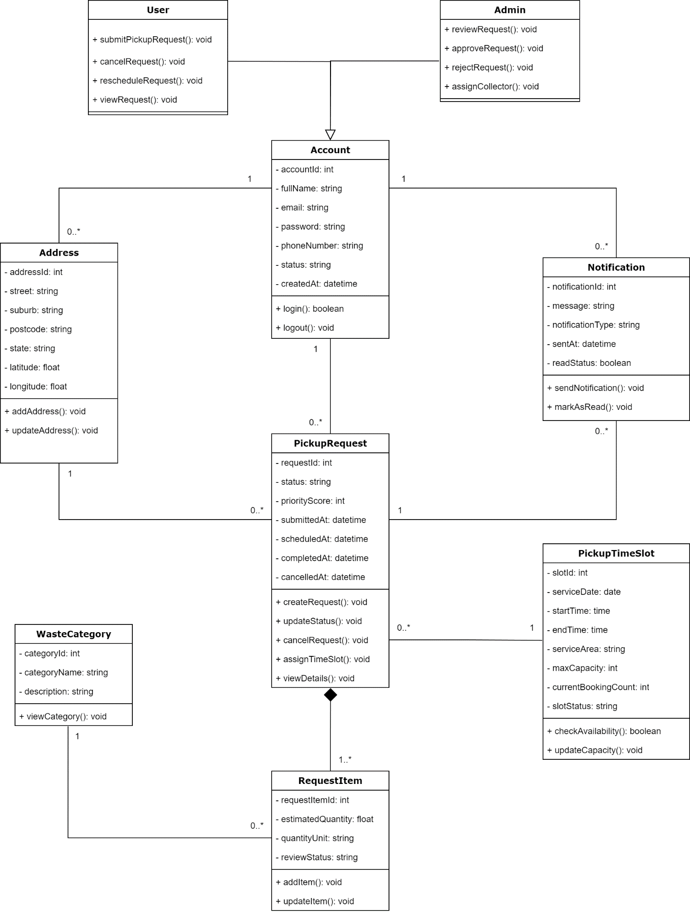
Class Diagram for Recycling Pickup Scheduler System

Class Diagram Explanation (Recycling Pickup Scheduler)
This class diagram represents the structure of the Recycling Pickup Scheduler system, showing the main classes, their attributes, methods, and how they relate to each other.

1. Account, User, and Admin
At the top of the system is the Account class, which stores common information such as name, email, password, phone number, and account status. It also includes basic functions like login and logout.
The system has two types of users:
- User
- Admin
Both of these inherit from Account, meaning they share the same basic information but have different responsibilities.
- User can:
  - submit a pickup request
  - cancel or reschedule a request
  - view request details
- Admin can:
  - review requests
  - approve or reject them
  - assign collectors
This separation helps organize the system based on user roles.

2. PickupRequest (Main Core Class)
The PickupRequest class is the central part of the system.
It stores all information related to a recycling pickup request, such as:
- request status
- priority score
- submission time
- scheduled time
- completion or cancellation time
It also provides key functions like:
- creating a request
- updating its status
- cancelling it
- assigning a time slot
Basically, most system actions revolve around this class.

3. Address
The Address class stores location details like street, suburb, postcode, and coordinates.
- One Account can have multiple addresses
- Each PickupRequest is linked to one address
This allows users to schedule pickups at different locations.

4. PickupTimeSlot
The PickupTimeSlot class represents available time slots for collection.
It includes:
- service date and time
- service area
- capacity and current bookings
Each pickup request is assigned to one time slot, while one time slot can handle multiple requests.
This helps manage scheduling and avoid overbooking.

5. RequestItem and WasteCategory
The RequestItem class represents the actual recyclable items in a request.
Each item includes:
- estimated quantity
- unit (e.g., kg)
- review status
Each item is linked to a WasteCategory, which defines the type of waste (e.g., plastic, paper).
- One PickupRequest contains one or more RequestItems
- Each RequestItem belongs to exactly one PickupRequest
This is shown using composition, meaning items cannot exist without a request.

6. Notification
The Notification class handles messages sent to users.
It includes:
- message content
- type of notification
- time sent
- read status
- One Account can receive many notifications
- Notifications can also be related to a pickup request
This helps keep users informed about updates like approvals or schedule changes.

7. Relationships Summary
- User/Admin → Account: inheritance (they share common data)
- Account → PickupRequest: one account can create many requests
- Address → PickupRequest: each request uses one address
- PickupTimeSlot → PickupRequest: one slot can have many requests
- PickupRequest → RequestItem: one request contains multiple items (composition)
- WasteCategory → RequestItem: each item belongs to a category
- Account → Notification: users receive notifications

8. Overall Idea
Overall, this diagram shows how the system is structured:
- Users create pickup requests
- Each request includes items and a location
- Requests are scheduled into time slots
- Admins manage and approve requests
- Notifications keep users updated
The design ensures that all parts of the system are connected and organized clearly.

